

**المملكة العربية السعودية**

**وزارة التعليم العالي**

**كليات المعرفة للعلوم و التقنية**

**كلية العلوم التطبيقية**

**قسم علوم الحاسب والمعلومات**

**Kingdom of Saudi Arabia**

**And the Ministry of Higher Education**

**Knowledge Colleges for Science and Technology**

**Faculty of Applied Science**

**Department of Computer and Information Sciences**

**_________________________________**

**GRADUATION PROJECT**

**Bakkah/ بَكَّة**

**Student names:**

**Bushra Ali ALsultan 191220448**

**Shorouq Mubarak ALanzi 191220244**

**Abrar Saud ALotaibie 201220173**

**Lama khalid alenazi 191220291**

**A report submitted in part fulfilment of the degree of BSc in Information Systems & Health Information Systems.**

**Supervisor:**

**Dr.Nisreen Innab**

**Department of Computer Science and Information System**

**Riyadh, Kingdom of Saudi Arabia**

Chapter 1 Problem definition 1-5

1.1 Project Description 1-0

1.2 Problem Statement 1-0

1.3 Objectives 1-0

1.4 Scope 1-1

1.5 Methodology 1-2

1.6 Functional Requirements 1-2

1.7 Non-Functional Requirements 1-2

1.8 System Context View 1-3

1.9 Challenges 1-4

1.10 Projections 1-4

1.11 Project time line 1-5

Chapter 2 System Architecture document 2-7

2.1 Introduction 2-0

2.2 System Architecture 2-0

2.3 Use case diagram 2-0

2.4 Class Diagram 2-1

2.5 Structural model 2-3

2.5.1 Entity Relationship Diagram (ERD) 2-3

2.6 Sequence Diagram 2-3

2.6.1 User registration sequence diagram 2-4

2.6.2 User login sequence diagram 2-4

2.6.3 Generating a QR code for Insurance card sequence diagram 2-5

Chapter 3 System Design Document 3-6

3.1 Introduction: 7

3.2 Use case documentation 7

3.3 Class diagram documentation 12

3.4 Activity Diagram 14

3.5 Interfaces 16

Chapter 4 Implementation 25

4.1 Introduction 26

4.1.1 Develop the IT infrastructure * 26

4.1.2 Develop the database and programs * 26

4.2 Implementation approach 26

4.2.1 Structured Programming * 27

4.2.2 Object-Oriented Programming * 27

4.3 Development environment 28

4.3.1 Android Studio 28

4.3.2 Android SDK 28

4.3.3 Firebase 29

Firebase: The Firebase Real-time Database is a cloud-hosted NoSQL database that lets you store, sync and query data between your users in real-time at global scale. 29

4.3.4 Example of Real-time database in Firebase 29

4.4 Programming language 29

4.5 Mapping from designing to Implementation 30

4.6 Code Readability and Maintainability 48

Chapter 5 Testing 50

5.1 Introduction 51

5.2 Mobile application testing issues 51

5.2.1 Some of the issues 51

5.3 Testing Methodologies 51

5.3.1 Functional Testing 52

5.3.2 Unit Testing 52

5.3.3 Integration Testing 52

5.3.4 System Testing 52

5.3.5 Acceptance Testing 52

5.3.6 Non-Functional Testing 53

5.3.7 Performance, Load, Stress Testing 53

5.3.8 Security, Vulnerability Testing 53

5.3.9 Usability Testing 53

5.3.10 Compatibility Testing 53

5.3.11 Black Box Testing 53

5.3.12 White Box Testing 54

5.3.13 Gray Box Testing 54

5.4 Test Plan 54

5.4.1 Functional Testing 54

5.5 Testing tools, Data, Environment 55

5.5.1 Testing environment 56

5.5.2 Factors for designing Test Environment 56

5.5.3 Environmental needs 56

5.5.4 Software 56

5.5.5 Others 56

5.6 Test cases 56

5.6.1 User Case 57

5.6.2 Security testing 63

Conclusions 65

Future Work 65

References 65

**Index of figures**

Figure 1- System Context View 1-4

Figure 2-Use case diagram 2-0

Figure 3-Class diagram 2-2

Figure 4-Entity relationship diagram 2-3

Figure 5-Sequence diagram-Register 2-4

Figure 6-Sequence diagram-Login 2-4

Figure 7-Sequence diagram-QR code generate 2-5

Figure 8-Activity Diagram 15

Figure 9-Interfaces-FirstPage 16

Figure 10-Interfaces-LoginOrReg 17

Figure 11-Interfaces-NewReg 18

Figure 12-Interfaces-MobileVer 19

Figure 13-Interfaces-RegSuccs 20

Figure 14-Interfaces-FingerPrintVer 21

Figure 15-Interfaces-Login 22

Figure 16-Interfaces-MainPage 23

Figure 17-Interfaces-QRcodeGenerated 24

Figure 18 - Example of Firebase Real-time database 29

Figure 19 - Register Sequence Diagram 31

Figure 20 - The register operation converted to code 32

Figure 21- The register operation converted to code 32

Figure 22- The register operation converted to code 33

Figure 23- The register operation converted to code 33

Figure 24- The register operation converted to code 34

Figure 25 - Register interface 35

Figure 26 - Login sequence diagram 36

Figure 27 - Login operation converted into code 36

Figure 28 - Login operation converted into code 37

Figure 29- - Login operation converted into code 37

Figure 30- Login operation converted into code 38

Figure 31- Login operation converted into code 38

Figure 32 - Login interface 39

Figure 33 - Mobile Verification operation into code 40

Figure 34 - Mobile Verification Interface 41

Figure 35 - Generating QR code sequence diagram 42

Figure 36 - Generate QR code turned into code 42

Figure 37- Generate QR code turned into code 43

Figure 38- Generate QR code turned into code 44

Figure 39- Generate QR code turned into code 45

Figure 40 - Generate QR code Interface 46

Figure 41- Generate QR code Interface 47

Figure 42 - Example of descriptive name 49

Figure 43- Testing Methods. 52

Figure 44 - User Cases 55

Figure 45- User case 57

Figure 46 - First Screen 58

Figure 47 - Main screen 59

Figure 48 - Corrected and Uncorrected Registered. 60

Figure 49- Invalid Login 61

Figure 50 - Valid Login 62

Figure 51- QR code fngerprint passed 63

Figure 52 - Security Testing 64

# Problem definition

## Project Description

## Bakkah to facilitate the transactions of pilgrims during the Hajj season, a wallet is designed to be used for all types of payments, including those made through credit cards. The individual fee can be collected into the Kingdom upon arrival, and the remainder is returned upon departure. Similar to a credit card e-wallet in that it can be linked to a bank account. The electronic wallet mainly contains two components, a program and personal information, and a high security that is not subject to piracy, and a QR is added to facilitate the process of renting moving vehicles through this service, in addition to providing pilgrims with knowledge of the frequency transmission points in terms of place and time.

## Problem Statement

There are several factors that affect first: the absence of an ATM near the Haram, second: the non-exchange of different currencies of five hundred and less denominations, and third: the assistance that applies to the elderly and those with special protests. Fourth: It helps in knowing the times and paths of the pilgrimages. Fifthly, it helps reduce the risk of theft.

## Objectives

The main objective of Bakkah is the design of an electronic wallet to preserve the money of pilgrims and provide services that contribute to the goals of the vision in the Kingdom of Saudi Arabia.

The objectives that to be achieved fromBakkah system application are:

* Ease of handling money.
* Easy currency conversion.
* Locate the nearest frequency transmission station.
* Provide trolley service.
* To participate in achieving vision 2030 targets.

## Scope

Analyzing the problem and to assist in drawing, organizing and knowing the outputs of the system, we need to know the stakeholders.

1. **Clients**
2. **Government (Aljawazat)**
3. **Elderly people and people with special needs**
4. **Banks**

The scope will define the boundaries of the application, which include functionalities as the following:

* **User registration**
* To register a new user profile.
* **Technical Linkage with Aljawazat**
* To compare with the Email to verify the identity
* **Email verification**
* To verify the identity of the user
* **QR code generator**
* To generate a QR code every time needed
* **Creating a database to store information**
* **Define the application language**
* **Building the application**
* **Testing for the application**
* **Launching the application**

## Methodology

## The methodology is as follows, we will study the current situation by creating a questionnaire to collect the results, then we will analyze the results of the study, and then we decide to apply for a private IBAN account number with the bank.

## Functional Requirements

Functional requirements are statements describing tasks and functions that the user can perform, also they capture the intended behavior of system by specifying functions that the system must be able to perform.

1. **Registration:** The pilgrim must register in the application using his email and password.
2. **Linking the IBAN:** Each account must be linked to the IBAN after registration.
3. **Login:** All users who use the application need to log in to their accounts to use the application functions by entering the email, password and the email verification step number entered in the system.
4. **Forgot password:** User can return his password.
5. **Scan a unique QR code:** The customer can scan a unique QR code after successfully completing the email verification step, and this code will be used to withdraw the required amount and take advantage of other features in the application.
6. **Show QR Code**: The app will display the generated QR Code to be scanned at the selected location.
7. **Terminating the QR code:** When the time set to the QR code ends or the QR code has been scanned, the QR code expires, to prevent using the QR code again.
8. **Comparison of information with (Passports):** Compare the visa number that has been set with the national number of each pilgrim every time he logs into the application and generates a QR code.

## Non-Functional Requirements

The non-functional requirements are the features to be in the system which used to obtain more efficiency. They include:

**Security**

* + New registration in the app.
  + Connecting the system to a Aljawazat
  + Connecting the system to a personal email.
  + International bank account.
  + Passwords consist of 8 characters and contain large letters and numbers.
  + The system will carry a user account 7 days when logging in and creating a QR code.
  + Before creating any QR code, there must be a step to verify the user's identity that includes a code sent to email.
  + Every QR code expires after 20 seconds.
  + Every QR code generated is different to enforce security.

**Usability**

* The user should be able to submit any request within 3 or 4 steps maximum.
* The user should be able to learn to use the system within 20 minutes.

**Privacy**

* The app requires the username, password and email sent when login.
* The system must keep information confidential so that other users are not allowed to view the information.

**Availability**

* The system should be available for 24 hours/7 days a week.

**Performance**

* Response time should be fast, so the user should be able to moves between system pages in few seconds**.**
* The system's response time is quick to retrieve and compare the data to generate the QR code in a quick manner.

## System Context View

Person (user) visits a Mecca To perform Hajj or Umrah The application is downloaded through his phone for Create or import e-wallets. The he person (user) logs in to the application. He enters the visa number his to verify the data. Thae's Linkingking the IBAN and The money that is added to the wallet is automatically transferred to Saudi riyals. The functions that the user can perform, money can be saved and retrieved in the future and Send money to other addresses; The person (user) can scan a QR code is added to facilitate the process of renting moving vehicles through this service, in addition to providing pilgrims with knowledge of the frequency transmission points in terms of place and time. In addition to Reservation for Zamzam Water Packing. All operations are stored in a database for easy retrieval.

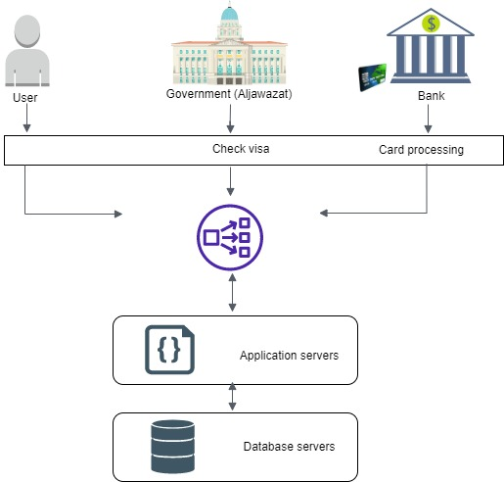

## Challenges

There are challenges that we might face in this project like learning how to use some of new methods, skills or programing languages for example:

* Learning a new application coding language to develop the application.
* Looking and using the simplest yet best tools for constructing and analysis to minimize the time cost .
* Communication and linkage with the government (Aljawazat).
* IBAN processing and linkage with the bank.
* Generate QR Code .
* Some research on the project points.

## Projections

## Know the people who are interested in the project idea, and contribute to their own expectations. Implementation of a good appropriate plan, taking care to announce the objectives of the project. Possess a culture that cares about achieving the project's goal. Relying on a committed, efficient and committed team. Building good communication channels. Use case diagram

## From describing the functions of the system from the user's perspective and defining each function of the operator or operator Study of prospective customers The project owner studies the desires and needs of potential customers, their numbers, descriptions, and whereabouts, in order to match the project’s products or services that will be offered in the target market, where knowledge of the customer is the basis for the success of any project Describe the environment in which the system will operate, such as interfaces with power sources, other equipment, software, databases, and users. Safety requirements may be included in the operating environment for the purposes of the system requirements report .

## Project time line

We made a plan for the entire project, including all the sub task that we need to complete in this project, shown in the table below:

|  |  |  |  |  |  |  |
| --- | --- | --- | --- | --- | --- | --- |
|  | Task | Duration | Start | | Finish | Resource |
| 1 | Bakkah Application | 2 days | Tuesday  6/9/2022 | | Wednesday  7/9/2022 | Bushra , Shorouq  Abrar , Lama |
| 2 | project proposal | 3days | Thursday  8/9/2022 | | Saturday  10/9/2022 | Bushra , Shorouq  Abrar , Lama |
| 3 | **Chapter 1** | **20 days** | **Sunday**  **11/9/2022** | | **Friday**  **30/9/2022** | **Bushra , Shorouq**  **Abrar , Lama** |
| 4 | Project Description | 1 day | Sunday  11/9/2022 | | Sunday  12/9/2022 | Bushra , Shorouq  Abrar , Lama |
| 5 | Problem Statement | 1 day | Monday  12/9/2022 | | Monday  13/9/2022 | Bushra , Shorouq  Abrar , Lama |
| 6 | Objectives | 1 day | Tuesday  13/9/2022 | | Tuesday  14/9/2022 | Bushra , Shorouq  Abrar , Lama |
| 7 | Scope | 1 day | Wednesday  14/9/2022 | | Wednesday  15/9/2022 | Bushra , Shorouq  Abrar , Lama |
| 8 | Methodology | 1 day | Thursday  15/9/2022 | | Thursday  16/9/2022 | Bushra , Shorouq  Abrar , Lama |
| 9 | Functional Requirements | 2day | Friday  16/9/2022 | | Saturday  18/9/2022 | Shorouq |
| 10 | Non-Functional Requirements | 1 days | Monday  18/9/2022 | | Monday  19/9/2022 | Bushra |
| 11 | System Context View | 4 days | Monday  18/9/2022 | | Thursday  22/9/2022 | Abrar |
| 12 | Challenges | 4 days | Monday  18/9/2022 | | Thursday  22/9/2022 | Abrar |
| 13 | Projections | 2 days | Friday  23/9/2022 | | Saturday  24/9/2022 | Lama |
| 14 | Project time line | 1day | | Saturday  24/9/2022 | Saturday  24/9/2022 | Bushra, Shorouq |
| 15 | Presentation | 4 days | | Sunday  25/9/2022 | Friday  30/9/2022 | Bushra , Shorouq  Abrar , Lama |

# System Architecture document

## Introduction

This chapter contains many of important topics with related subjects, these subjects are: (System Architecture, Design decisions, Domain model, Architectural Style, Structural model).To their importance for considered the building blocks for application to be implemented, and finally we will depict some diagrams, to illustrate the functionality of the application.

## System Architecture

## System architecture is a compact, manageable description of how a system is organized and how the components inter operate .The system architecture is often the same for systems with similar requirements .

## Use case diagram

A use case is a method that used in the system analysis to model the requirements of the system. The use case is involving of a group of processes that interact with the systems. The predictable users are show in determined environment and related to a particular objective. It offers a group of components that can be used together. The use case should describe all system activities that have relations to the users as show in Figure **.**

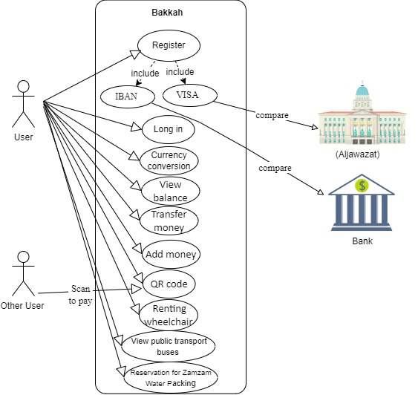

## Class Diagram

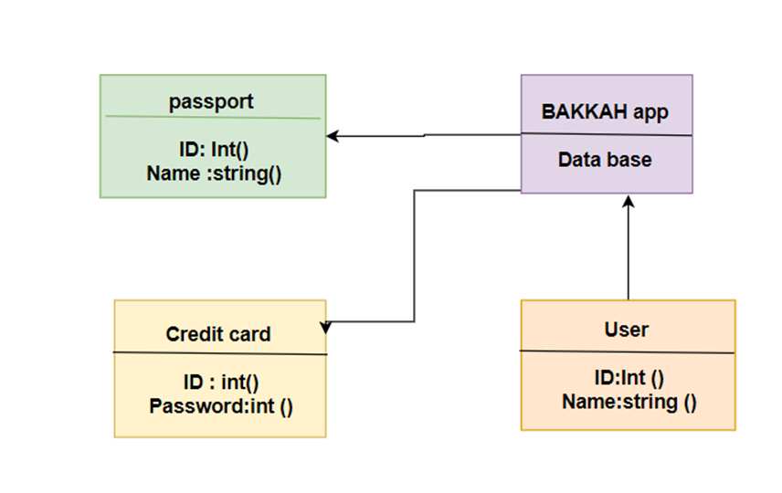

## Structural model

## 

### Entity Relationship Diagram (ERD)

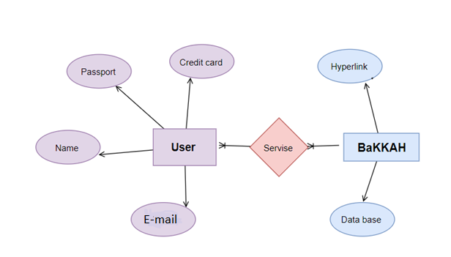

## Sequence Diagram

Sequence diagrams are interaction diagram that displays how processes work with one another and in what order. It is a construct of a Message Sequence. A sequence diagram displays object interactions arranged in time sequence. It shows the objects and classes involved in the scenario and the sequence of messages exchanged between the objects. It needed to carry out the functionality of the scenario as show in Figures

### User registration sequence diagram

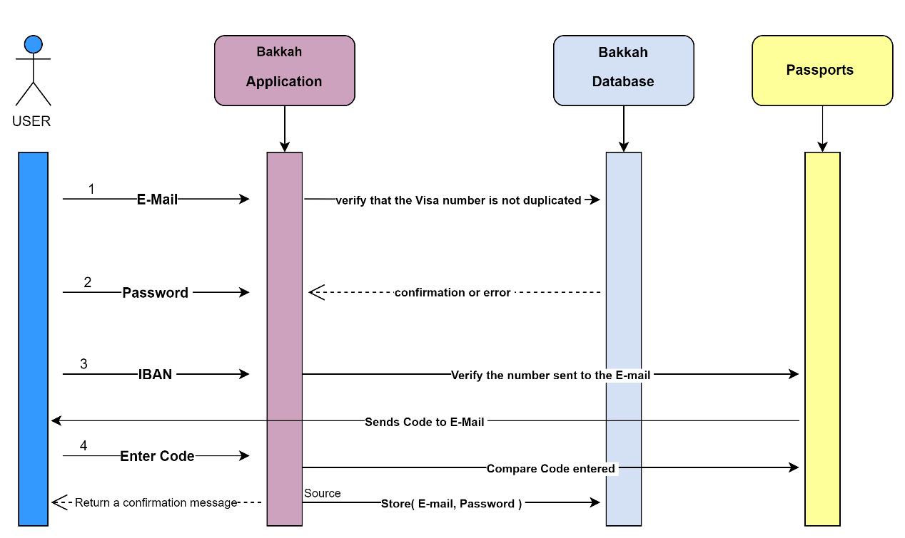

### User login sequence diagram

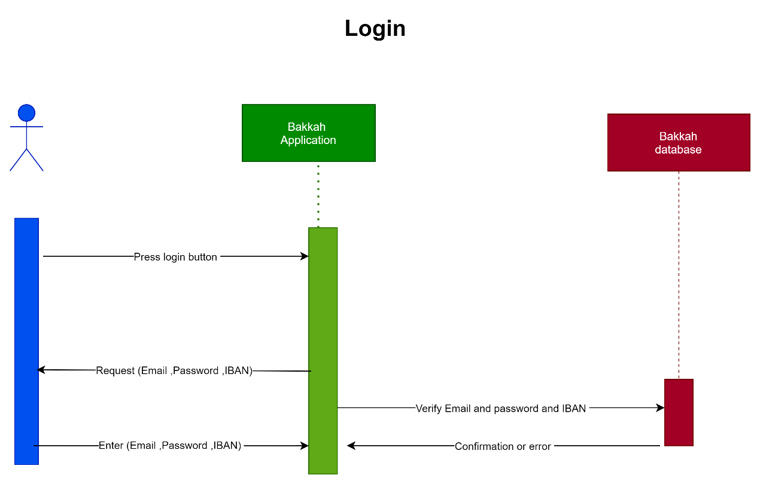

### Generating a QR code for Insurance card sequence diagram

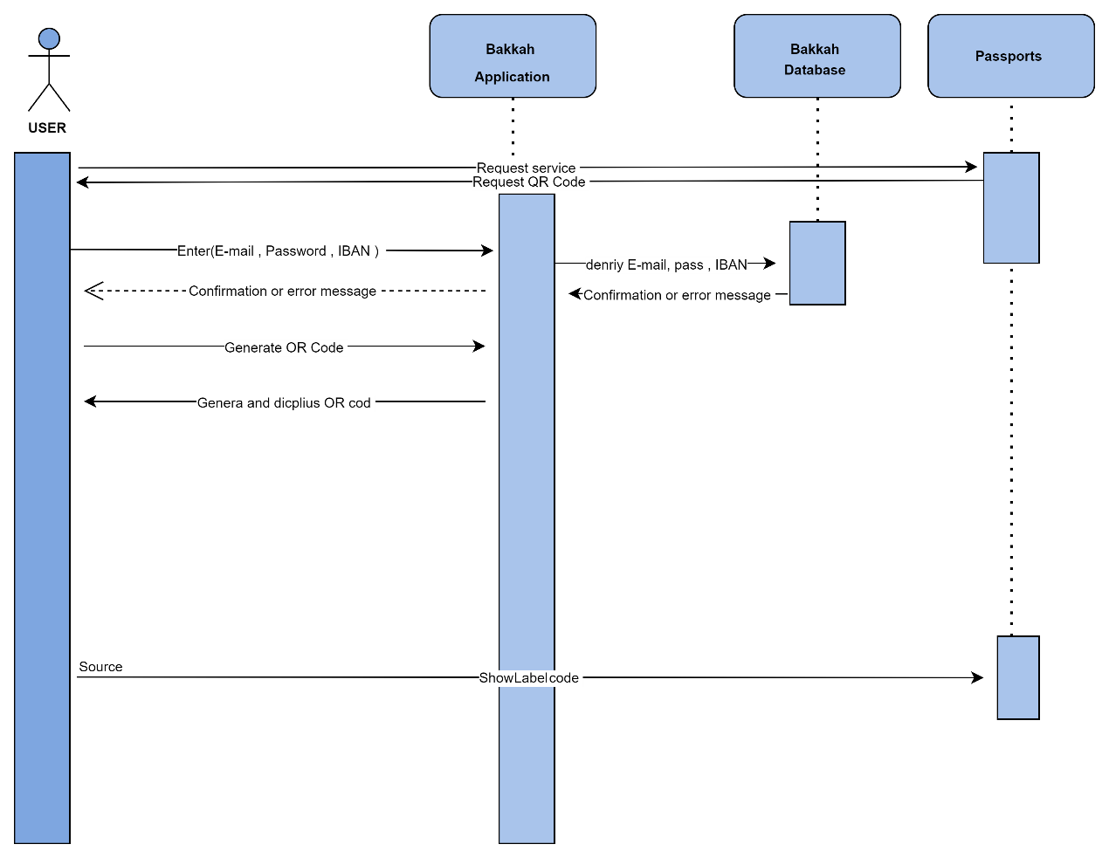

# System Design Document

## References

https://www.diagrams.net/